Web Portal on Ubuntu EC2 with DynamoDB Integration
Virtual Private Cloud (VPC) :
VPC (Virtual Private Cloud) is a private, isolated network in AWS that allows you to securely run resources like EC2 instances.
You can control IP ranges, subnets, route tables, and gateways
Steps:
  - Go to VPC Dashboard → Create VPC.
  - Set IPv4 CIDR block (e.g., 10.0.0.0/16).
  - Create subnets (public for EC2, private if needed).
  - Create an Internet Gateway and attach it to your VPC.
Update route tables to allow internet access for public subnet
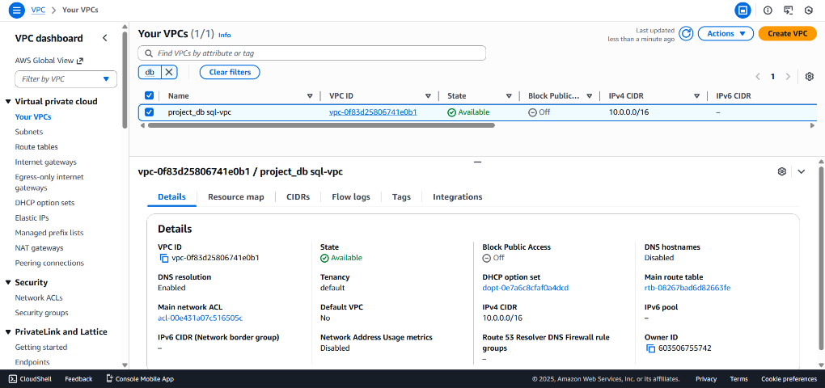
Launch an EC2 Instance
Go to EC2 Dashboard → Launch Instance.
Name: project_db sql-vpc
AMI: Ubuntu Server 22.04 LTS
Instance type: t2.micro
Key pair: Select or create a new key
Network settings:
VPC: web-portal-vpc
Subnet: web-public-subnet
Auto-assign public IP: Enable
Security Group:
Allow HTTP (80), SSH (22), HTTPS (443)
Click Launch Instance
Generate and download key pair (.pem) for SSH
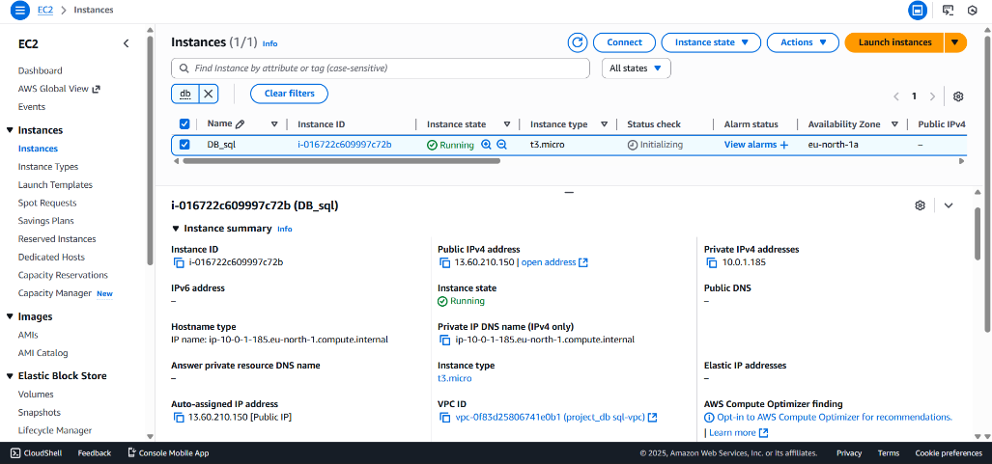
Connect to EC2 and Install Packages
ssh -i your-key.pem ubuntu@13.60.210.150
sudo apt update -y
sudo apt install apache2 php php-mysqli mysql-client -y
sudo systemctl enable apache2
sudo systemctl start apache2
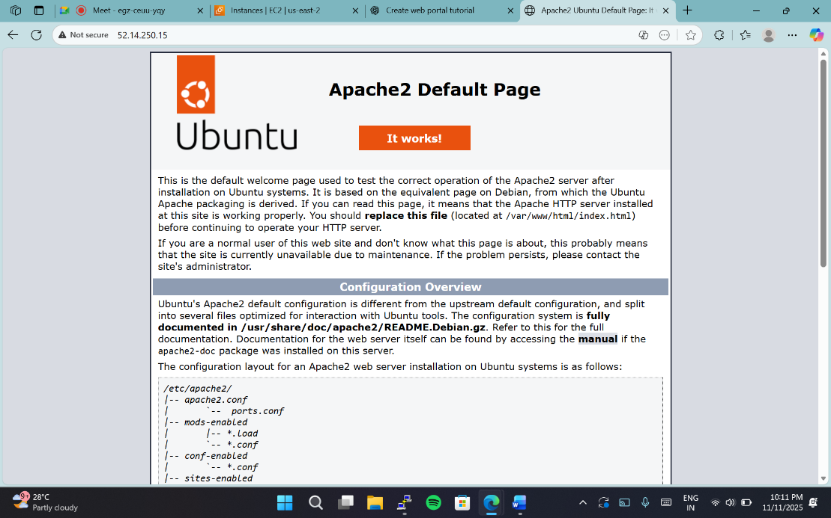
Create an RDS MySQL Database
Go to RDS → Databases → Create Database
Engine: MySQL
Template: Free Tier
DB instance identifier: mywebdb
Master username: admin
Password: (choose strong password)
Public access: Yes
VPC Security Group: Allow port 3306 inbound from your EC2’s security group.
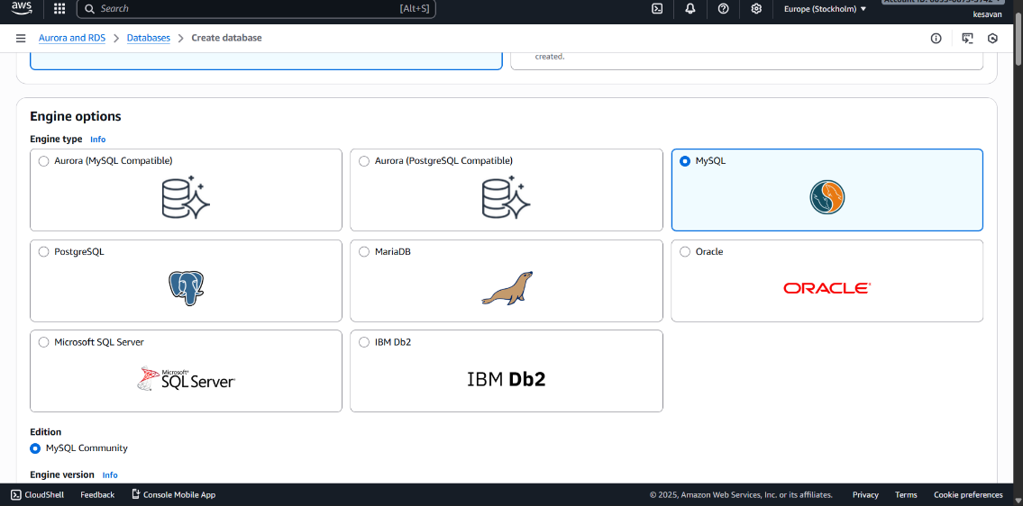
Create Database and Table
mysql -h mywebdb.xxxxxx.us-east-1.rds.amazonaws.com -u admin -p
Once inside My sql:
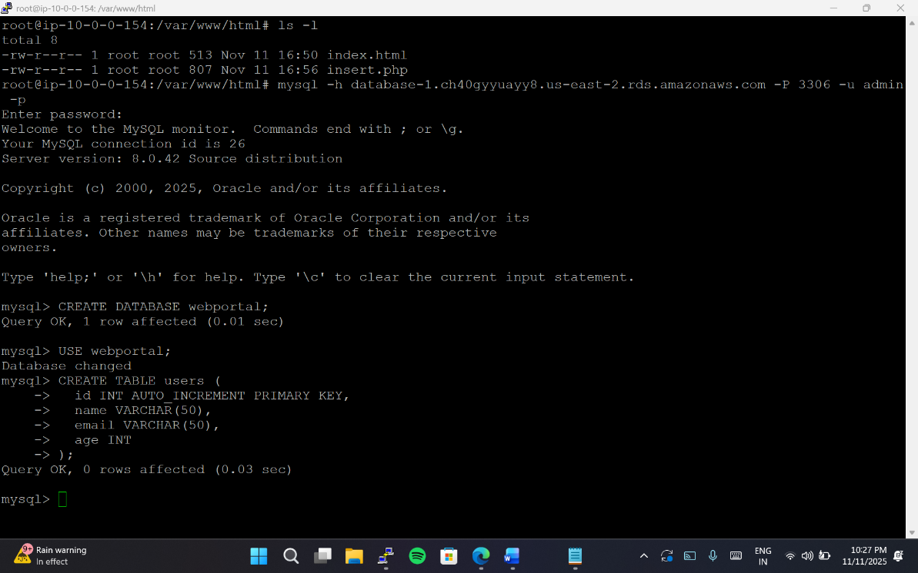
Create Web Portal (HTML + PHP)
cd /var/www/html
sudo rm index.html
Create HTML Form (index.html)
<!DOCTYPE html>
<html>
<head>
<title>Web Portal</title>
</head>
<body>
<h2>Enter User Details</h2>
<form action="insert.php" method="post">
<label>Name:</label>
<input type="text" name="name" required><br><br>
<label>Email:</label>
<input type="email" name="email" required><br><br>
<label>Age:</label>
<input type="number" name="age" required><br><br>
<input type="submit" value="Submit">
</form>
</body>
</html>
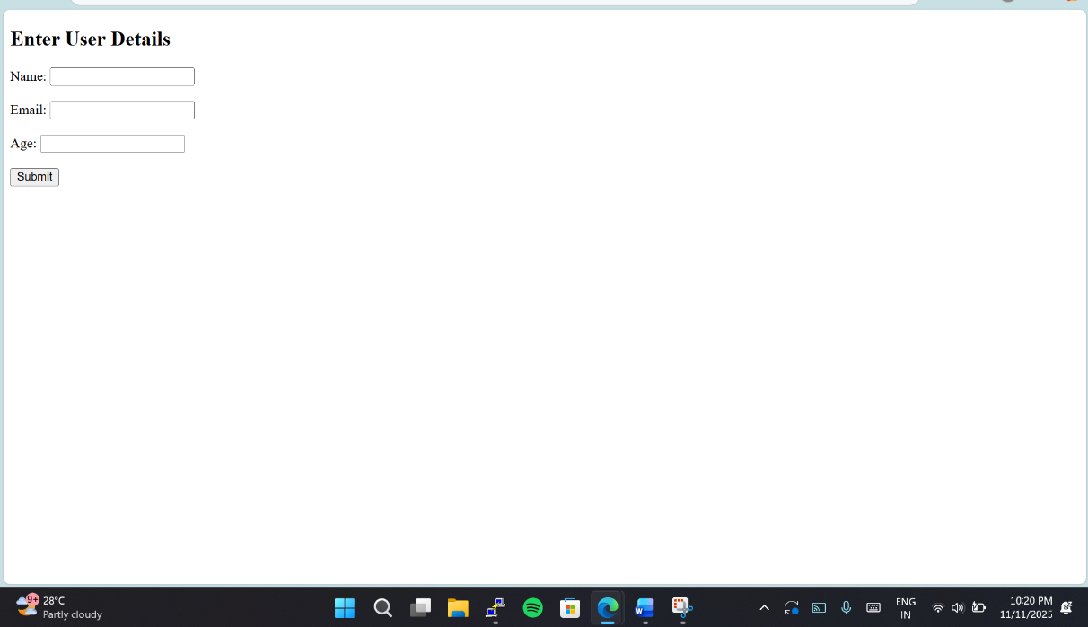
Create PHP Backend (insert.php)
sudo nano insert.php
Restart Apache
sudo systemctl restart apache2
Test the Portal
Open browser:
http://<EC2-Public-IP>/index.html
Fill Name, Email, Age
Click Submit
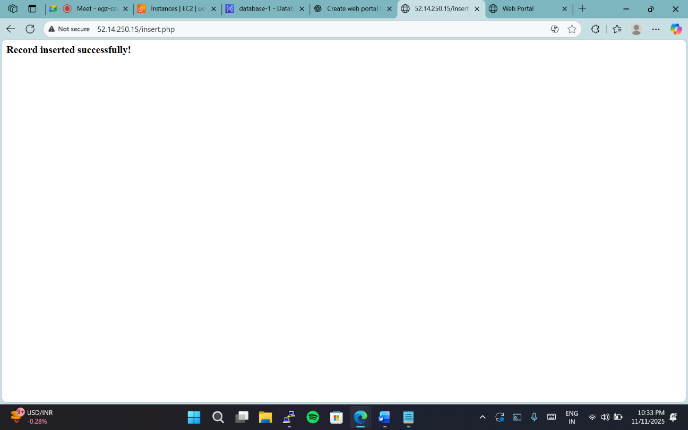
Verify in MySQL
Back in EC2 terminal:
mysql -h mywebdb.xxxxxx.us-east-1.rds.amazonaws.com -u admin -p -D webportal
SELECT * FROM users;
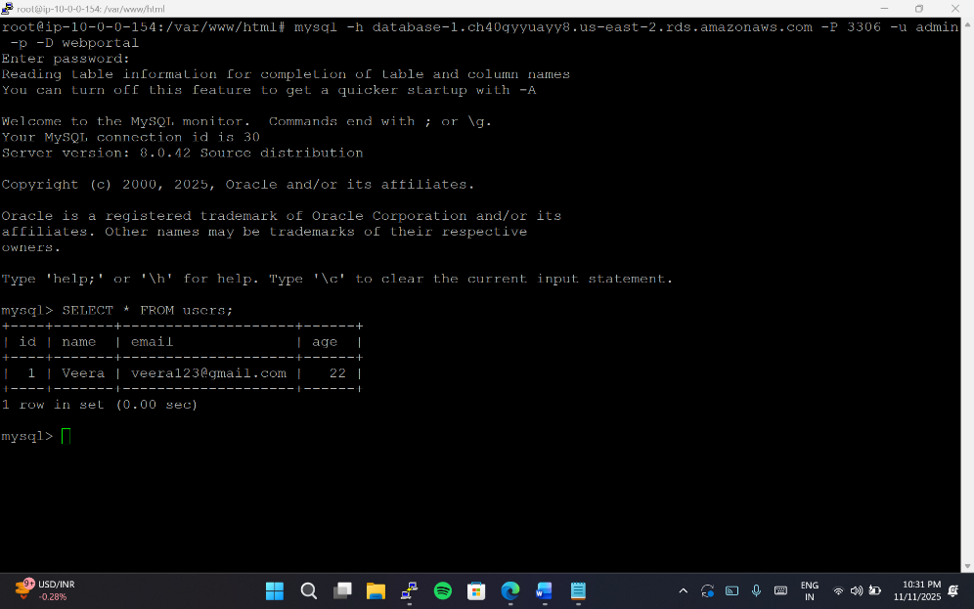
we have done:
Apache web portal using HTML form
PHP backend connected to MySQL (RDS)
Successfully inserted records into RDS database

